Home Page Structure
- Create a simple wireframe sketch (on paper or using a free tool like Figma or Canva) for the home page of a food delivery app similar to Zomato, showing the main sections you would include and their layout.
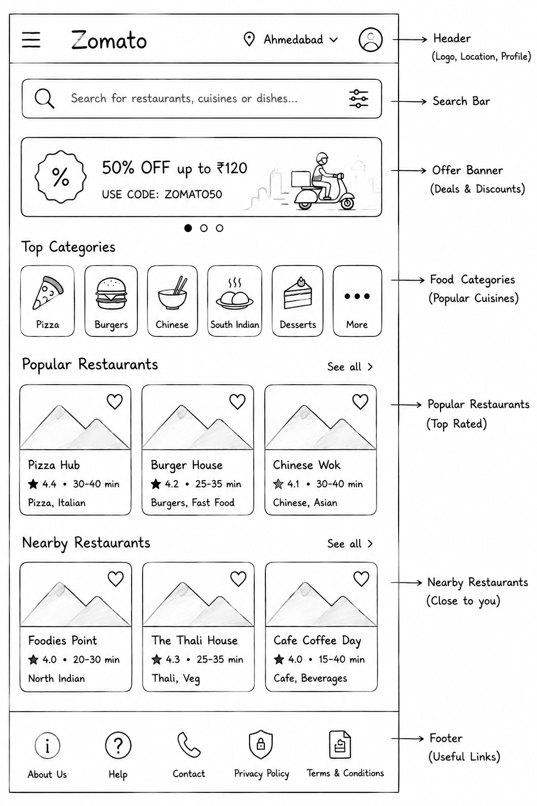

- Design an HTML structure for a home page of a music streaming app like Spotify, including a header, navigation bar, featured playlists section, and a footer. Use only HTML, no CSS or images yet.
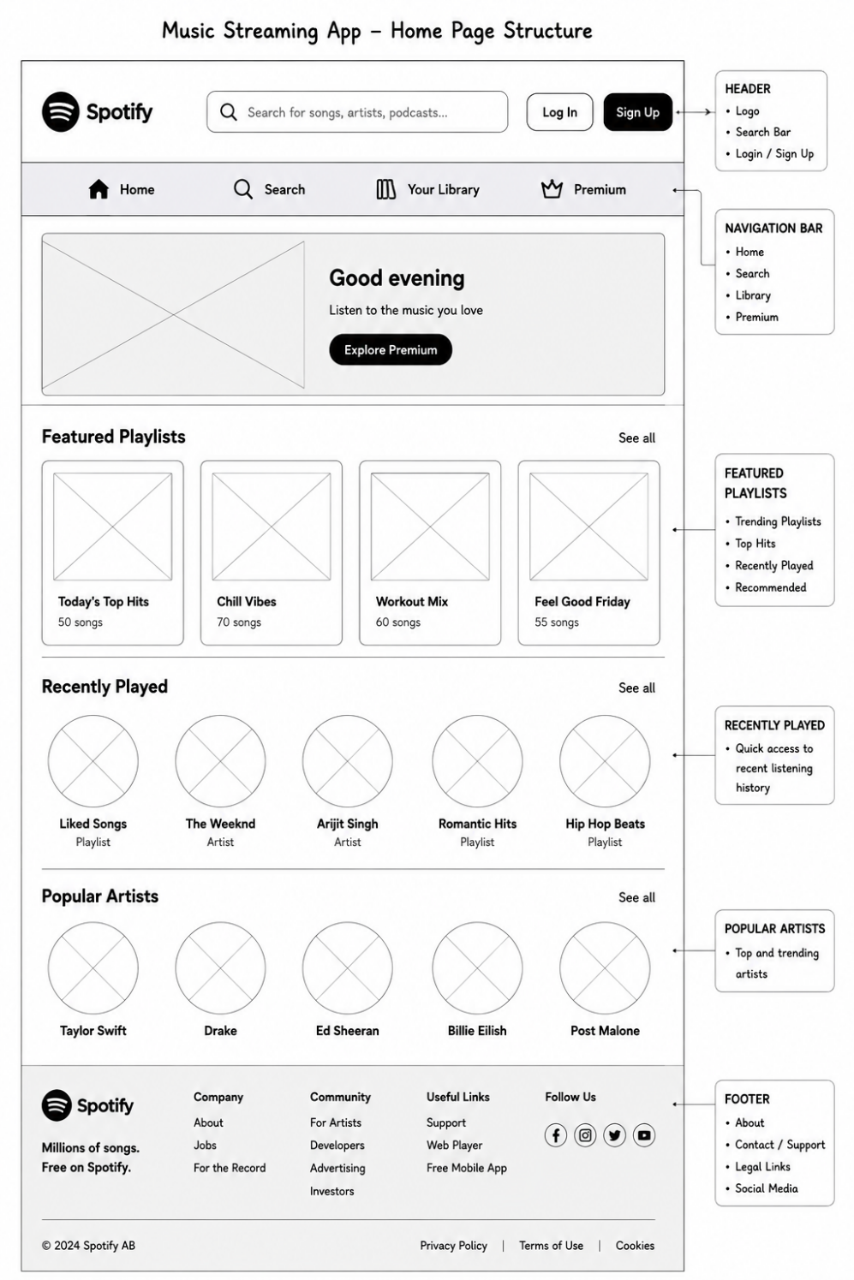

- List 5 essential elements that should appear above the fold (visible without scrolling) on an e-commerce home page like Flipkart, and explain in one line why each is important.

Essential Element | Importance
Search Bar | Helps users quickly find products they want.
Logo | Builds brand identity and trust.
Navigation Menu | Allows users to browse product categories easily.
Promotional Banner | Highlights special offers and attracts customers.
Cart & User Account Icons | Provides quick access to shopping cart and account information.
- Open the home page of any popular app you use (Instagram, Swiggy, BookMyShow, etc.) and note down the first three sections or features you see. Write a short paragraph on how the order of these sections helps user engagement.
- Answer (Example: Instagram)
- Stories
- Feed Posts
- Bottom Navigation Bar
Paragraph:
Instagram first displays Stories because they contain fresh content that encourages immediate interaction. Below the Stories, users see personalized feed posts based on their interests, which keeps them engaged for longer periods. The bottom navigation bar provides quick access to Search, Reels, Messages, and Profile, making it easy for users to explore different features and continue using the app smoothly.

